Jeremiah Pecku

CTEC 298

12/27/22

Numpy tutorial

Numpy tutorial 1

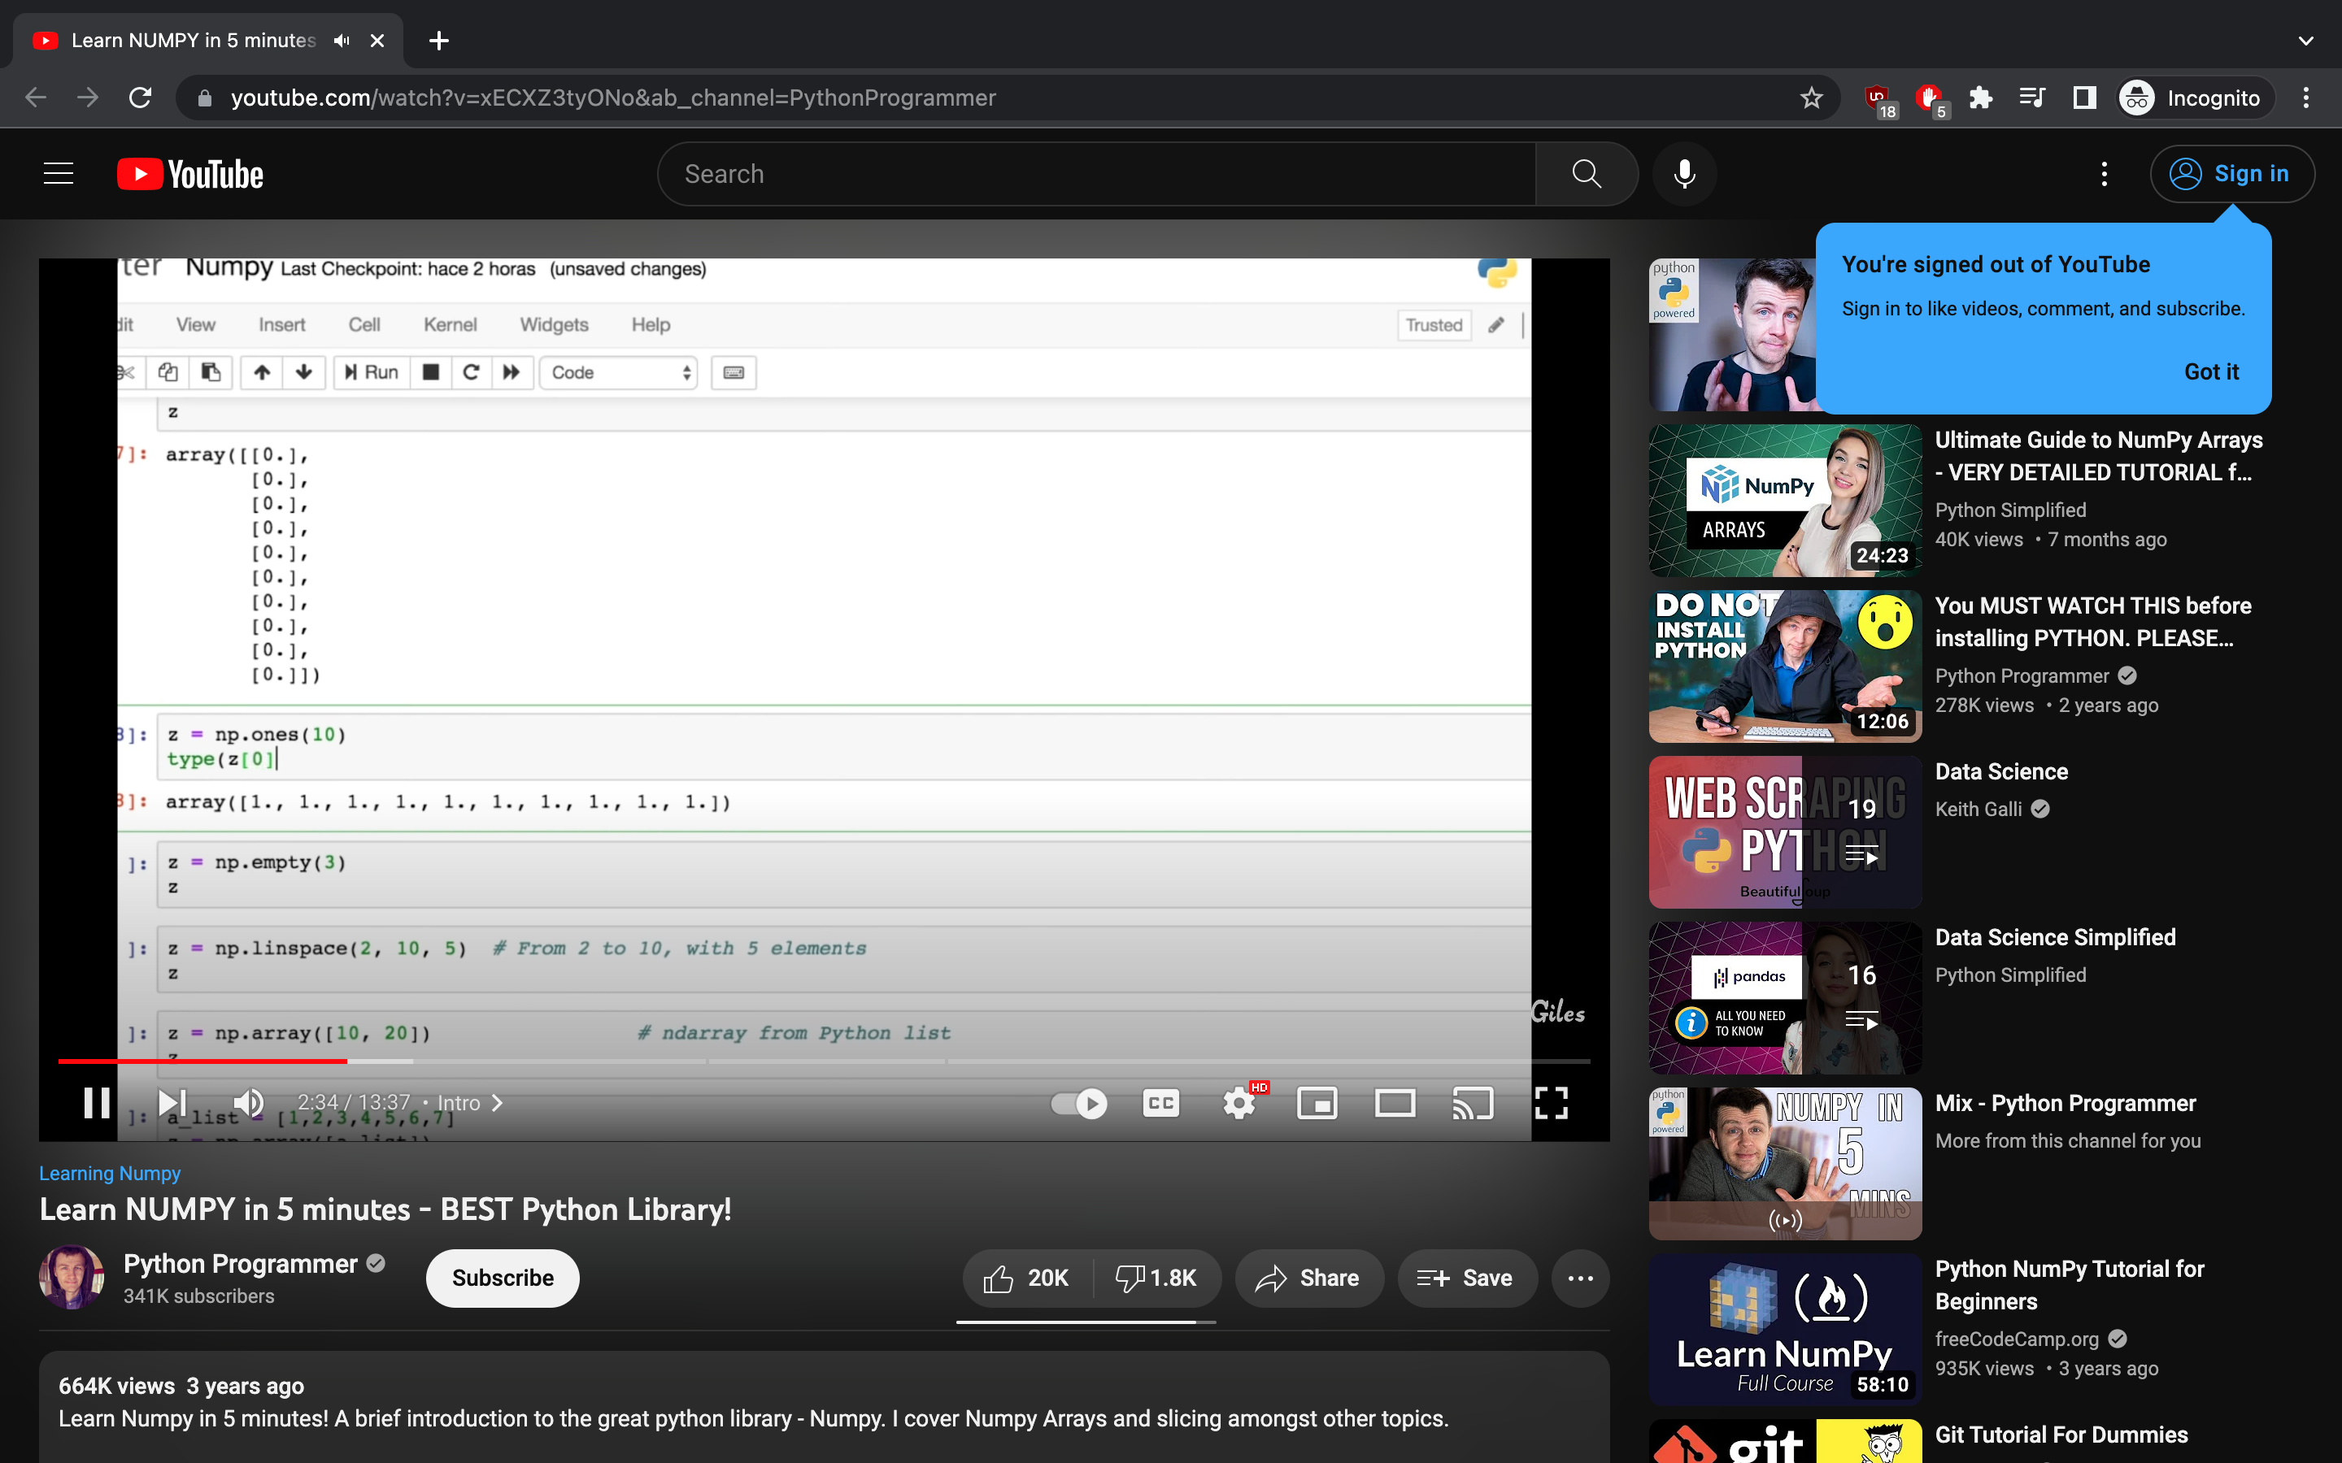

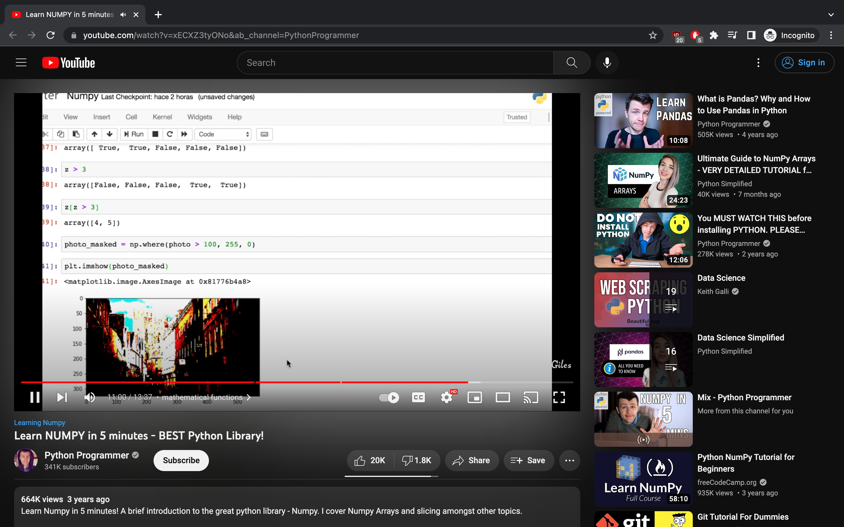

Numpy tutorial 2

